Image Gallery Software

Use-Case-Realization Specification: View Gallery

Version <1.0>

Revision History

|  |  |  |  |
| --- | --- | --- | --- |
| **Date** | **Version** | **Description** | **Author** |
| 17/12/2020 | <1.0> | <details> | Do Minh Hieu |
|  |  |  |  |
|  |  |  |  |
|  |  |  |  |

Table of Contents

1. Introduction 2

1.1 Purpose 2

1.2 Scope 2

1.3 Definitions, Acronyms, and Abbreviations 2

1.4 References 2

1.5 Overview 2

2. Use-Case Specification 4

3. Interaction Diagrams 5

4. Class Diagrams 2

3. Derived Requirements 2

Use-Case-Realization Specification: View Gallery

# Introduction

## Purpose

This document describes how the View Gallery Use-Case is realized within the design model, in terms of collaborating objects.

## Scope

This document applies to the Image Gallery Software which will be developed Group 5C-18.

## Definitions, Acronyms, and Abbreviations

User – a person who use the software.

## References

None.

## Overview

In the following section, Use-Case Realization Specification of the View Gallery Use-Case of the Image Gallery Software is provided in detail. The first section is a textual description of the Use-Case specification. The following section contains diagrams (sequence and collaboration diagrams) describing how the use case is realized in terms of collaborating objects. The third section includes class diagrams with relationships that participate in the realization of the use case. The last section is an analysis of all requirements, such as non-functional requirements, on the use-case realization that are not considered in the design model, but that need to be taken care of during implementation.

# Use-Case Specification

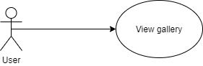

|  |  |
| --- | --- |
| **Name** | View Gallery |
| **Brief Description** | Viewing user’s gallery which store all user’s image has posted in the software. |
| **Actor** | User |
| **Flow of Events** | |
| **Basic Flow** | |
| 1. User click on “Gallery” button on menu bar. 2. Retrieve all images of the user from database. 3. List of images which user has been posted will appear. | |
| **Alterante Flows** | |
| **Title** | **Description** |
| None. |  |
| **Pre-Conditions** | |
| Not empty field. | |
| **Post-Conditions** | |
| **Title** | **Description** |
| Success | A list images of user appear. |
| **Extension Points** | |
| None | |

# Interaction Diagrams

**Sequence Diagram:**

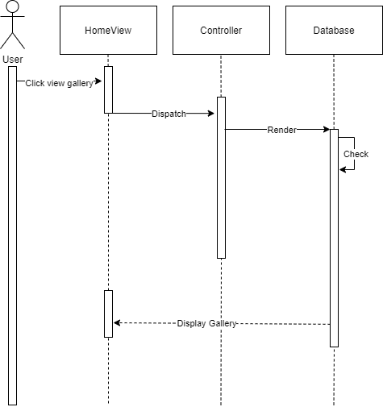

**Collaboration Diagram:** 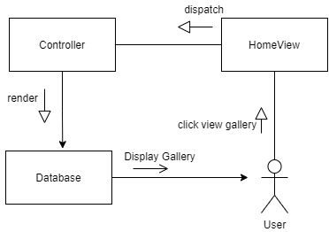

# Class Diagrams

# 

# Derived Requirements

None.